**DSA0159**

**Assignment - 1**

**P.YOSHA REDDY**

**(192111135)**

1. What is the exact output of the program below?

#include <iostream>

using namespace std; int main()

{ int n = 4, k = 2; cout << ++n << endl; cout << n << endl; cout << n++ << endl; cout << n << endl; cout << -n << endl; cout << n << endl;

cout << --n << endl;

cout << n << endl;

cout << n-- << endl; cout << n << endl;

cout << n + k << endl; cout << n << endl; cout << k << endl; cout << n << k << endl; cout << n << endl; cout << " " << n << endl; cout << " n" << endl; cout << "\n" << endl; cout << " n * n = "; //CAREFUL!

cout << n * n << endl; cout << 'n' << endl;

return 0;

}

**OUTPUT:**

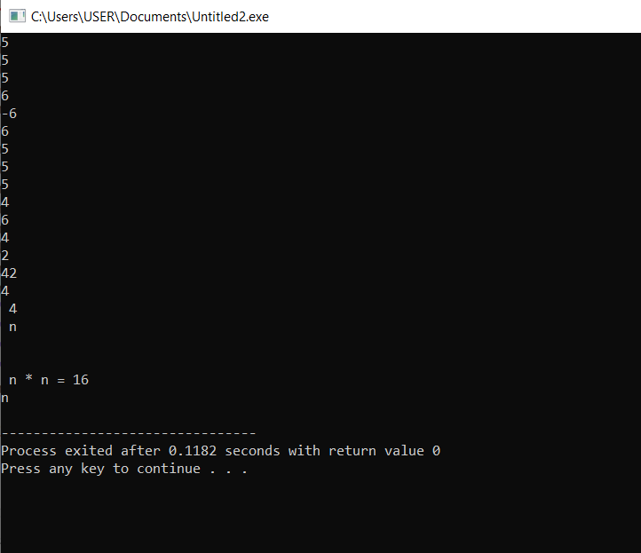

2. What is the output of the program below? #include <iostream>

using namespace std;

int main()

{ int n = 3; while (n >= 0)

{

cout << n * n << endl;

--n;

}

cout << n << endl;

while (n < 4)

cout << ++n <<endl;

cout << n << endl;

while (n >= 0)

cout << (n /= 2) << endl; return 0;

}

**OUTPUT:**

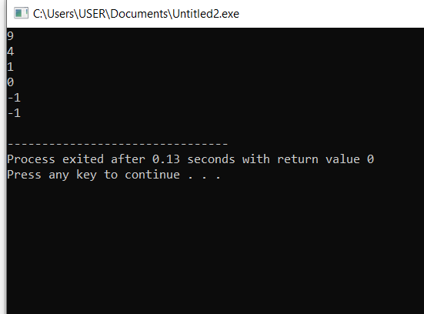

1. What is the output of the program below?

#include <iostream>

using namespace std;

int main()

{

int n;

cout << (n = 4) << endl;

cout << (n == 4) << endl; cout << (n > 3) << endl; cout << (n < 4) << endl; cout << (n = 0) << endl; cout << (n == 0) << endl; cout << (n > 0) << endl; cout << (n && 4) << endl; cout << (n || 4) << endl; cout << (!n) << endl; return 0;

}

**OUTPUT:**

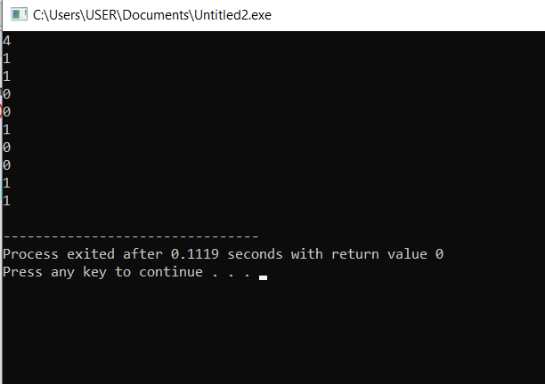

1. What is the output of the following program?

#include <iostream>

using namespace std;

int main()

{ enum color_type {red, orange, yellow, green, blue,violet};

color_type shirt, pants;

shirt = red;

pants = blue;

cout << shirt << " " << pants << endl;

return 0;

}

**OUTPUT:**

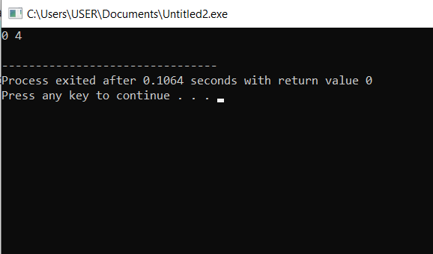

1. What is the output when the following code fragment is executed?

int i = 5, j = 6, k = 7, n = 3; cout << i + j * k - k % n << endl; cout << i / n << endl;

**OUTPUT:**

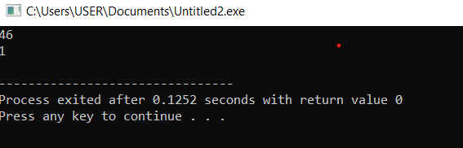

1. What is the output when the following code fragment is executed?

int found = 0, count = 5; if (!found || --count == 0) cout << "danger" << endl; cout << "count = " << count << endl;

**OUTPUT:**

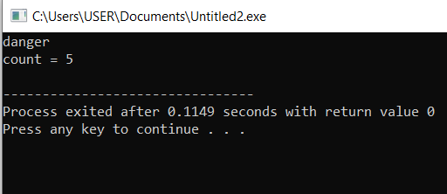

1. The loop shown below has been written by an inexperienced C++ programmer. The behavior of the loop is not correctly represented by the formatting.

int n = 10; while (n > 0) n /= 2; cout << n * n << endl;

1. What is the output of the loop as it is written?

**0**

1. Correct the syntax of the loop so that the logic of the corrected loop corresponds to the formatting of the original loop. What is the output of the corrected loop?

**25**

1. Correct the formatting of the (original) loop so that the new format reflects the logical behavior of the original loop.

**CORRECTED CODE:**

#include <iostream>

using namespace std;

int main()

{

int n = 10;

while (n > 0)

{

n /= 2;

cout << n * n << endl;

return 0;

}

}

1. Remove all the unnecessary tests from the nested conditional statement below. float income;

cout << "Enter your monthly income: ";

cin >> income;

if (income < 0.0)

cout << "You are going farther into debt every month." << endl;

else if (income >= 0.0 && income < 1200.00)

cout << "You are living below the poverty line." << endl;

else if (income >= 1200.00 && income < 2500.00)

cout << "You are living in moderate comfort." << endl;

else if (income >= 2500.00)

cout << "You are well off." << endl;

**OUTPUT:**

float income;

cout << "Enter your monthly income: ";

cin >> income;

if (income < 0.0)

cout << "You are going farther into debt every month." << endl;

else if (income >= 0.0 && income < 1200.00)

cout << "You are living below the poverty line." << endl;

else if (income >= 1200.00 && income < 2500.00)

cout << "You are living in moderate comfort." << endl;

else

cout << "You are well off." << endl;

1. Answer the questions below concerning the following fragment of code.

int n;

cout << "Enter an integer: ";

cin >> n;

if (n < 10)

cout << "less than 10" << endl; else if (n > 5)

cout << "greater than 5" << endl; else

cout << "not interesting" << endl;

1. What will be the output of the fragment above if the interactive user enters the integer value 0 ?

**Less than 10**.

1. What will be the output of the fragment above if the interactive user enters the integer value 15 ?

**Greater than 5**

1. What will be the output of the fragment above if the interactive user enters the integer value 7 ?

**Less than 7**

1. What values for n will cause the output of the fragment above to be "not interesting"?

**OUTPUT**

int n;

cout << "Enter an integer: ";

cin >> n;

**if (n > 10)** //changed the comaprision.

cout << "less than 10" << endl; **else if (n < 5)**

cout << "greater than 5" <<endl;

else

cout << "not interesting" << endl;

**//THE OUTPUTS WILL BE 5,6,7,8,9,10.**

**NOT INTERESTED.**

10. Rewrite the following code fragment so that it uses a "do...while..." loop to accomplish the same

task.

int n;

cout << "Enter a non-negative integer: "; cin >> n;

while (n < 0)

{

cout << "The integer you entered is negative." << endl; cout << "Enter a non-negative integer: "; cin >> n;

}

**REWRITING CODE WITH do…while loop:**

#include <iostream>

using namespace std;

{

int main()

int n;

do {

cout << "Enter a non-negative integer: ";

cin >> n;

if (n < 0) {

cout << "The integer you entered is negative." << endl;

}

} while (n < 0);

}